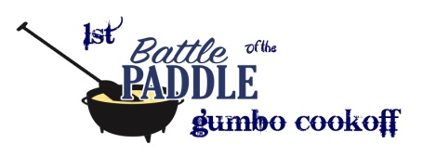

1st Battle of the Paddle Gumbo Cook Off
Vendor Booth Registration
Rules:
Set up by 8:00am if you are unloading from a vehicle by 10am if not. Gates open to the public at 10am.
Each vendor will be given a 10x10 space for $40.00. If you need more space you will have to purchase another 10x10 space. Only food products allowed will be jellies, jams, pickles or that kind of canned food or packaged mixes. No Cookies, brownies, popcorn, drinks, or concession type items can be sold.
Booths are available on a first come first serve basis so get there early for check in.
If you are planning on paying with a check it needs to be turned in by March 22, 2017 either by mail or in person at: Special Angels Rodeo/Gumbo cookoff 702 W. Division Ave Orange, TX 77630. This way they checks can be processed ahead of time. If you are planning on paying with cash you can the morning of but we need your information ahead of time to have you a spot. Call Jo at 409-670-6358 and reserve your spot.
Name_______________________________________________
Address______________________________________________
_____________________________________________________
Email address__________________________________________
Phone Number_________________________________________
What will you be selling__________________________________
_____________________________________________________
Office use only paid _____ Not paid_____ Cash __________ Check____________

