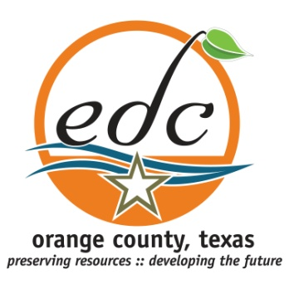

Orange County Economic Development Corporation
123 South 6th Street
Orange TX 77630
409-882-7070

For Immediate Release:
Orange County Hotel/Motel Tax Fund Applications Available

Orange County, Texas (February 22, 2016)—The Orange County Hotel/Motel Tax committee has released applications for non-profit entities within Orange County to apply for a portion of the County’s Hotel/Motel Tax funds. Any 501(C) organization in Orange County that attracts visitors to Orange County Texas can make application to the committee. There are a number of restrictions by state law as to how the funds can be utilized. First, the funds must be used in a manner that encourages overnight visitors to Orange County. Secondly, expenditures must fall within one of the following categories.

- Convention Centers and Visitor Information Centers: the acquisition of sites for and the construction, improvement, enlarging, equipping, repairing, operation and maintenance of convention center facilities or visitor information centers, or both;

- Registration of Convention Delegates: the furnishing of facilities, personnel, and materials for the registration of convention delegates or registrants;

- Advertising, Solicitations and Promotions that Directly Promote Tourism and the Hotel and Convention Industry: advertising and conducting solicitations and promotional programs to attract tourists and convention delegates or registrants to the county;

- Promotions of the Arts that Directly Promote Tourism and the Hotel and Convention Industry: that the encouragement, promotion, improvement, and application of the arts, including instrumental and vocal music, dance, drama, folk art, creative writing, architecture, design and allied fields, painting, sculpture photography, graphic and craft arts, motion picture, radio, television, tape and sound recording, and other arts related to the presentation, performance, execution, and exhibition of these major art forms,

- Historical Restoration and Preservation Activities that Directly Promote Tourism and the Hotel and Convention Industry: historical restoration and preservation projects or activities or advertising and conducting solicitation and promotional programs to encourage tourists and convention delegates to visit preserved historic sites or museums.

- Sporting Event Expenses that Substantially Increase Economic Activity at Hotels: Expenses including promotional expenses, directly related to a sporting event in which the majority of participants are tourists who substantially increase economic activity at hotels and motels within the county.

- Certain Portions of Sporting Facilities: Expenses for a certain percentage of a facility’s patrons that are directly contributing to increased local hotel activity.

- Shuttle Services for Convention Activities: Shuttle services for an event is an eligible expense provided the shuttle services begins or terminates at a local hotel facility.

Applications can be downloaded from the following media outlets:
KOGT – www.kogt.com
The Orange Leader – www.orangeleader.com
The Vidorian – www.thevidorian.com
Orange County Record – www.therecordlive.com

Applications will be accepted until 5:00 p.m. March 23, 2016 at the Orange County offices; 123 S 6th Street, Orange, TX 77630 or interested persons can call (409) 882-7070 and have an application mailed. The Hotel/Motel Tax Committee will review the applications and hold a public hearing in early April. An open meetings notification will be published. Those submitting applications will be notified directly. The committee will then make recommendations to the Orange County Commissioner’s Court for expenditure of the funds.

